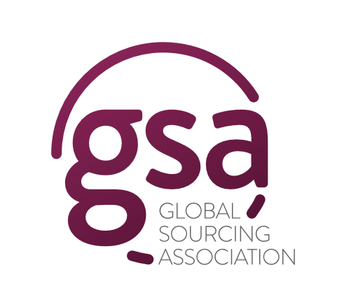
17th June 2022
GSA Announces the UK Awards 2022 Winners!
The Global Sourcing Association is delighted to announce the 2022 GSA UK Awards winners! The winners were announced on Thursday 16th June 2022 at the GSA UK Awards Ceremony at the Park Plaza Victoria in London.
Global Sourcing Association CEO, Kerry Hallard said:

“The ceremony was a phenomenal cerebration of our industry, and it was fantastic to be back celebrating our industry in person! The industry is enjoying its biggest economic boom ever, as a result of the fantastic work we did during the pandemic. We deserve this growth, as evidenced by the submissions, which demonstrate all the fantastic work that partnerships around the world have been doing. Congratulations to all.”

The UK Awards, now in their 19th year, recognise and celebrate the efforts of companies who have demonstrated best practice in Strategic Sourcing.
The Winners:

Utilities Project of the Year
E.on & Teleperformance

Telecommunications Project of the Year
Infosys BPM Ltd. and BT-EE

Retail Project of the Year
EXL

Healthcare Project of the Year
Wipro Limited

Financial Services Project of the Year
Diligenta (a subsidiary of Tata Consultancy Services)

Public Sector Project of the Year
The Royal Free London NHS Foundation Trust

International Project of the Year
Infosys BPM Ltd. and Telefonica UK Ltd.

Business Services Project of the Year
Firstsource & Post Office Insurance

Technology Enabled Project of the Year
NHS Shared Business Services and Medway NHS Foundation Trust

Automation Project of the Year
The Royal Free London NHS Foundation Trust

Digital Project of the Year
GEP

Transformation Project of the Year
Wipro Limited

Excellence in Partnership Collaboration
Durhamlane

Employer of the Year
Parseq

Social Programme of the Year
Webhelp

Shared Service Centre of the Year
NHS Shared Business Services

Law Firm of the Year
Ashurst

Advisory Firm of the Year
Neo Group Inc

Customer Experience Provider of the Year
Teleperformance

Service Provider of the Year
WNS Global Services Private Limited

Enterprise Buyer of the Year
E.on

Changemaker of the Year
UST

GSA Special Recognition Award
Intetics Inc

The Special Recognition Award was given to Intetics Inc for the fantastic work they are doing as the GSA Technology Partner, developing an app for all of the GSA’s future events. Intetics and their delivery team, working out of Ukraine, received a standing ovation from the awards ceremony guests.

About the GSA
The Global Sourcing Association (GSA) is the industry association and professional body for the global sourcing industry. We are the home of the Global Sourcing Standard, a world first for the provision of a portfolio of best practice methodologies and accreditation programmes supported by both buyers and suppliers of sourcing.

The GSA is a not-for-profit membership association which serves to share best practice, trends and connections across the globe bringing the global community together in a wholly interactive manner for the first time. Its overriding objective is the ongoing development and dissemination of the standard and supporting portfolio of qualifications in order to improve the benefits and positive reputation, and therefore size, of the global sourcing industry.

The Global Sourcing Association is a member of the Global Technology & Business Services Council, an alliance of leading associations and bodies across the globe including the United Kingdom, Poland, Romania, Bulgaria, Russia, Egypt, India, Ukraine, Latin America, Malaysia, Sri Lanka, South Africa and the United States.

For further information, please contact the GSA team at admin@gsa-uk.com

